Dependent T-tests

1. Type your data in as Time 1 in column 1 and Time 2 in column 2. Each person’s scores should be one row (my data is column 1 and 2).
2. 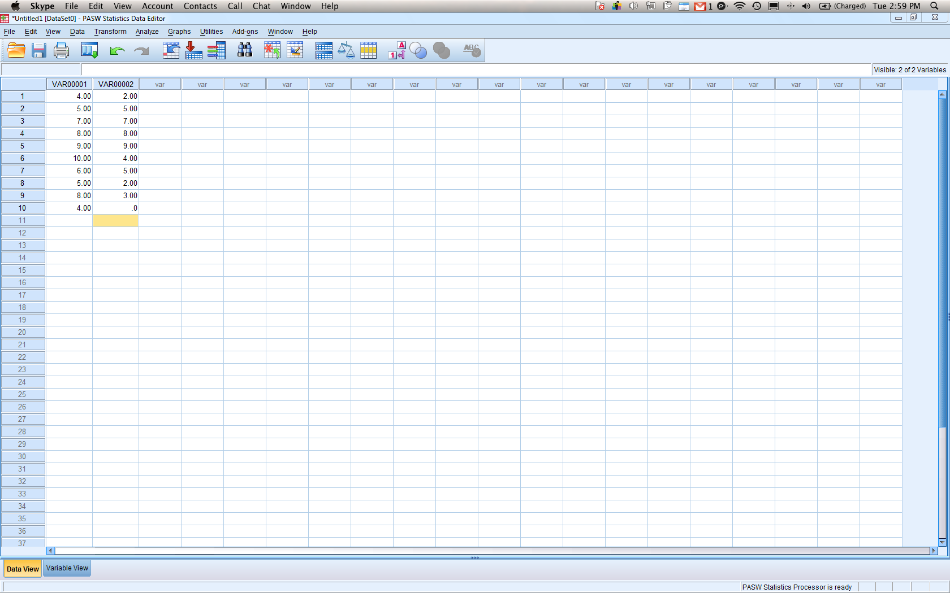
3. Click analyze > compare means > paired samples t-tests.
4. 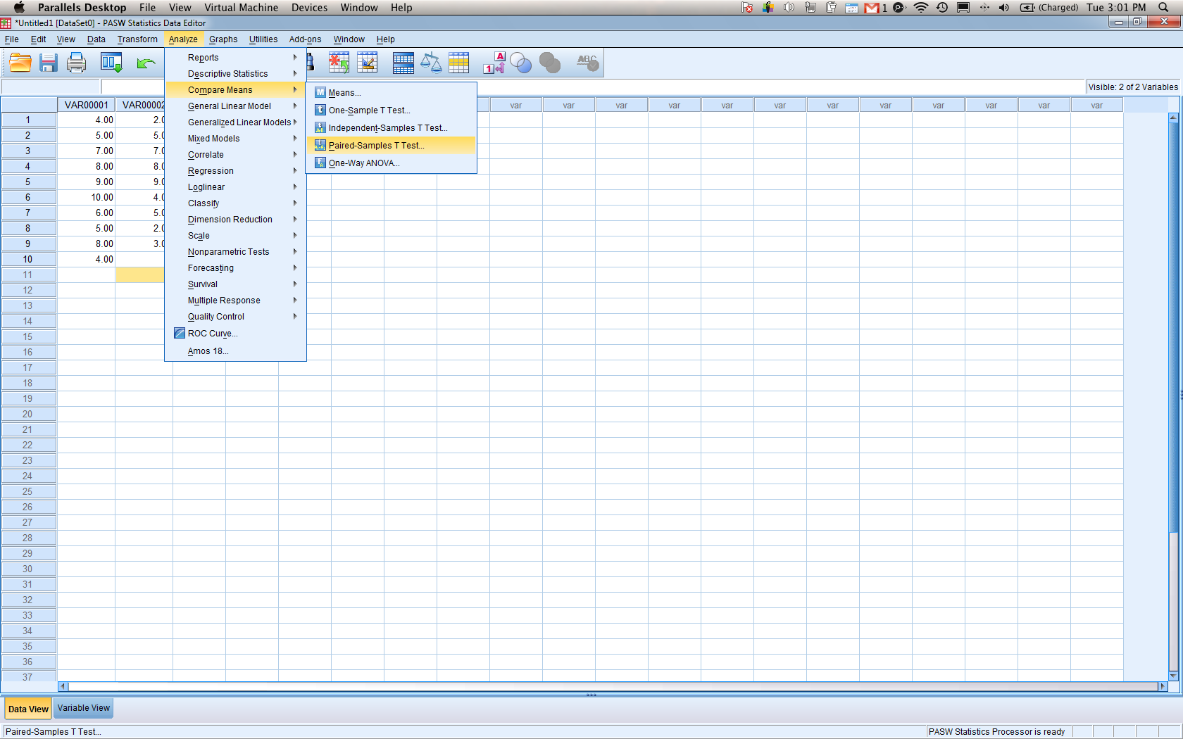
5. Click on both pairs together and hit the arrow key to move them to the right side. Hit ok.
6. 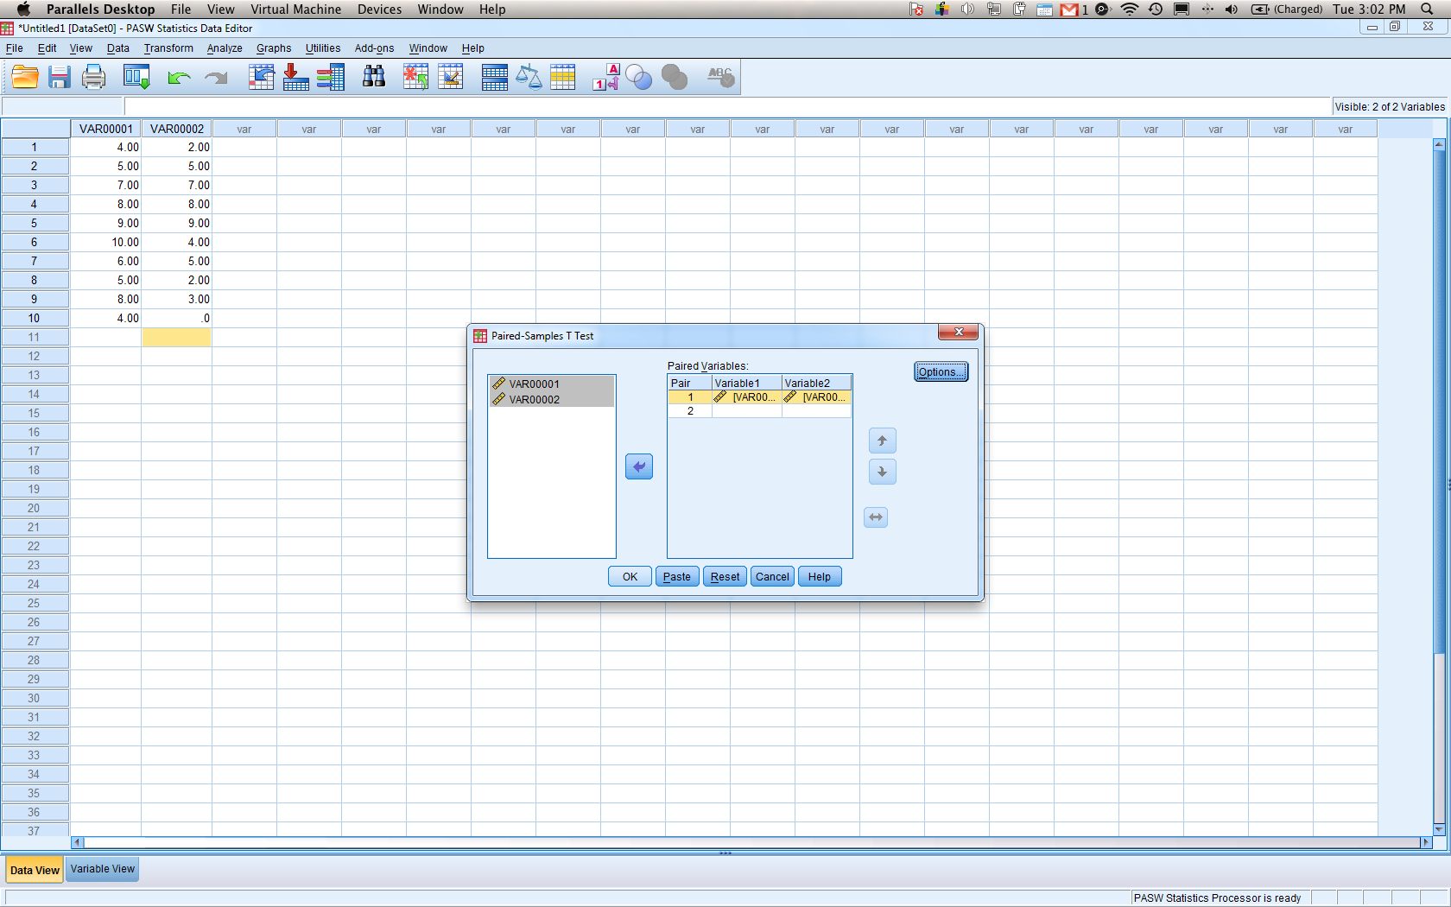

| **Paired Samples Statistics** | | | | | |
| --- | --- | --- | --- | --- | --- |
|  | | Mean | N | Std. Deviation | Std. Error Mean |
| Pair 1 | VAR00001 | 6.6000 | 10 | 2.11870 | .66999 |
| VAR00002 | 4.5000 | 10 | 2.87711 | .90982 |

| **Paired Samples Correlations** | | | | |
| --- | --- | --- | --- | --- |
|  | | N | Correlation | Sig. |
| Pair 1 | VAR00001 & VAR00002 | 10 | .620 | .056 |

| **Paired Samples Test** | | | | | | | | | |
| --- | --- | --- | --- | --- | --- | --- | --- | --- | --- |
|  | | Paired Differences | | | | | t | df | Sig. (2-tailed) |
| Mean | Std. Deviation | Std. Error Mean | 95% Confidence Interval of the Difference | |
| Lower | Upper |
| Pair 1 | VAR00001 - VAR00002 | 2.10000 | 2.28279 | .72188 | .46699 | 3.73301 | 2.909 | 9 | .017 |

1. First box:
   1. Var 001 – first column data, or time 1 mean, N number of people, Std. Deviation sample time 1 standard deviation, and Sm for Time 1.
   2. Var 002 – second column data, time 2 mean, N number of people, sample time 2 standard deviation, and Sm for Time 2.
2. Second box:
   1. Correlation between time 1 and time 2, not important for a paired samples t-test.
3. Third box:
   1. Mean = mean difference between time 1 and time 2.
   2. Std deviation = standard deviation of the difference between time 1 and time 2. (this is s)
   3. Std error mean = Sm for the difference between time 1 and time 2.
   4. 95% CI – lower and upper bound for the mean.
   5. t = t-value for the difference.
   6. df = degrees of freedom (N-1).
   7. Sig = p-value.